Singly Linked List
Perform the followings
Q1. Write the code snippet to define a Node structure for a Singly Linked List in C and C++.
C struct Node { // your code here };
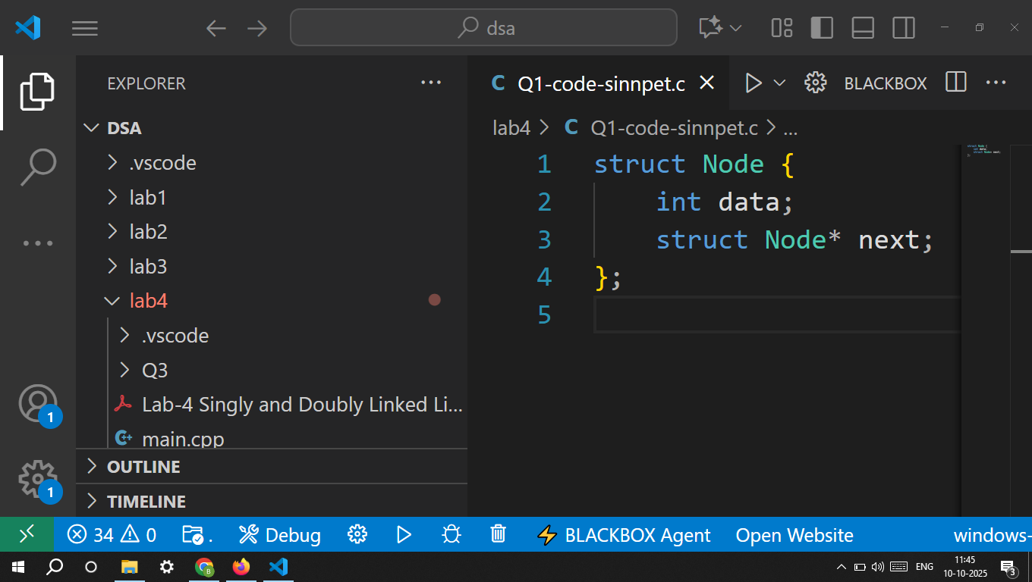

C++ class Node{ // your code here };
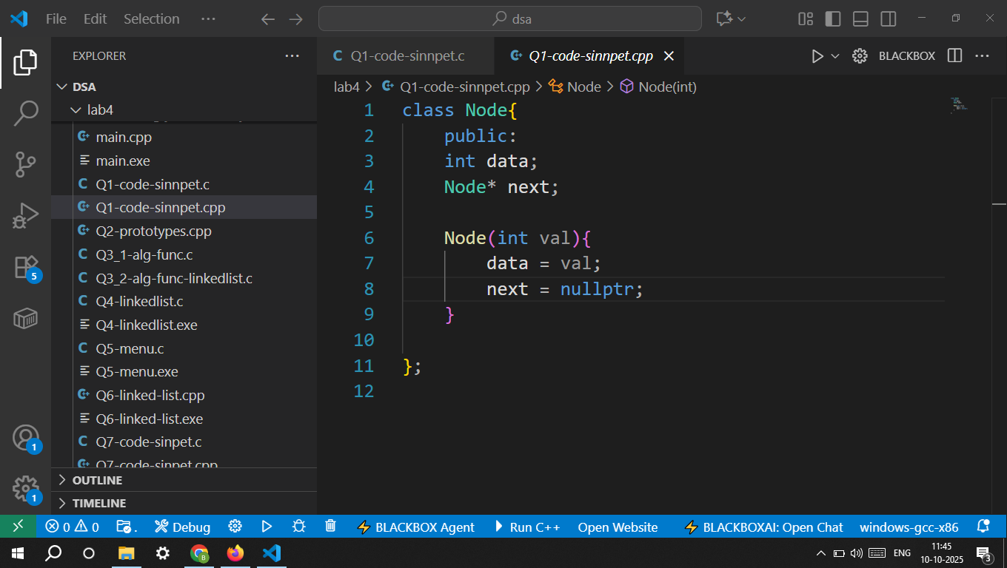

Q2. Write function prototypes for the following operations:
• Create a new node
• Insert at beginning
• Insert at end
• Insert after a specific position
• Delete from beginning
• Delete from end
• Delete a specific node
• Search an element
• Display the list
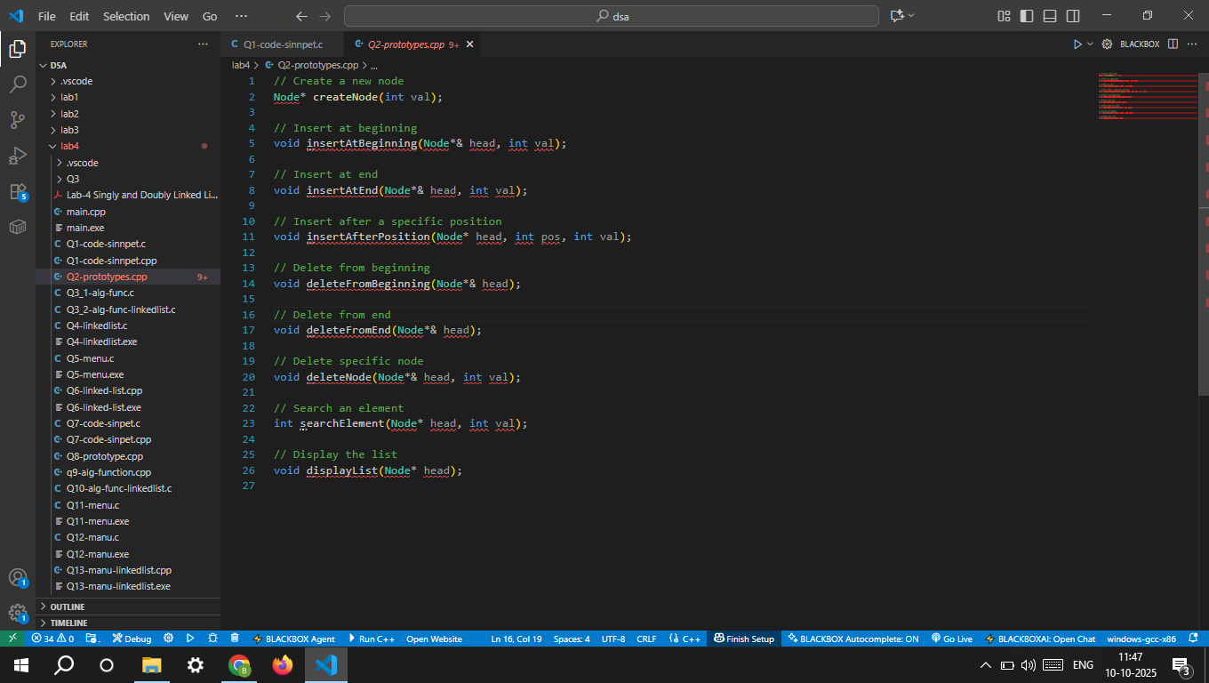

Q3. Read the following Algorithms for SLL Operations and implement them in C and C++
C: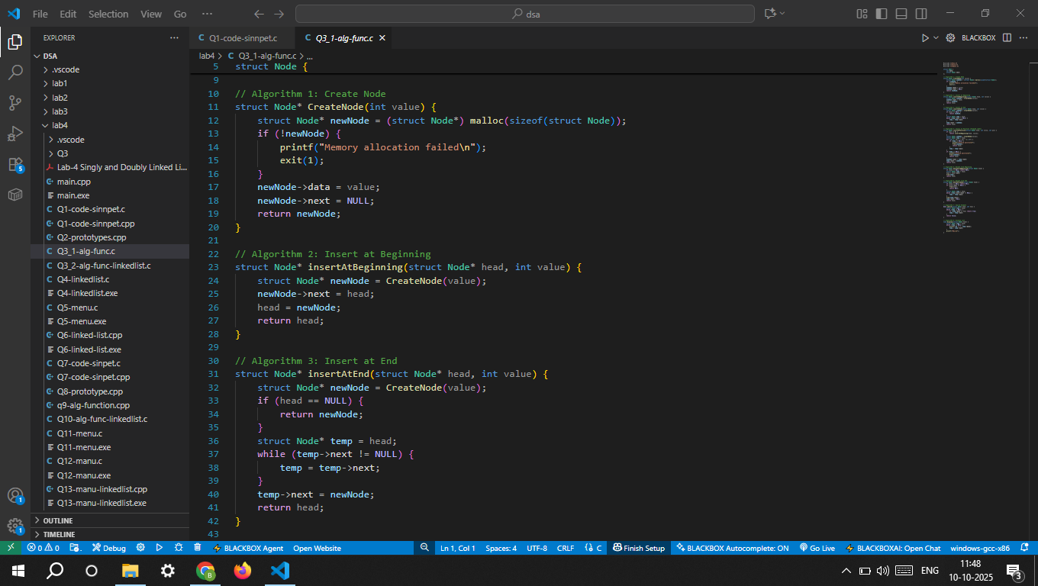
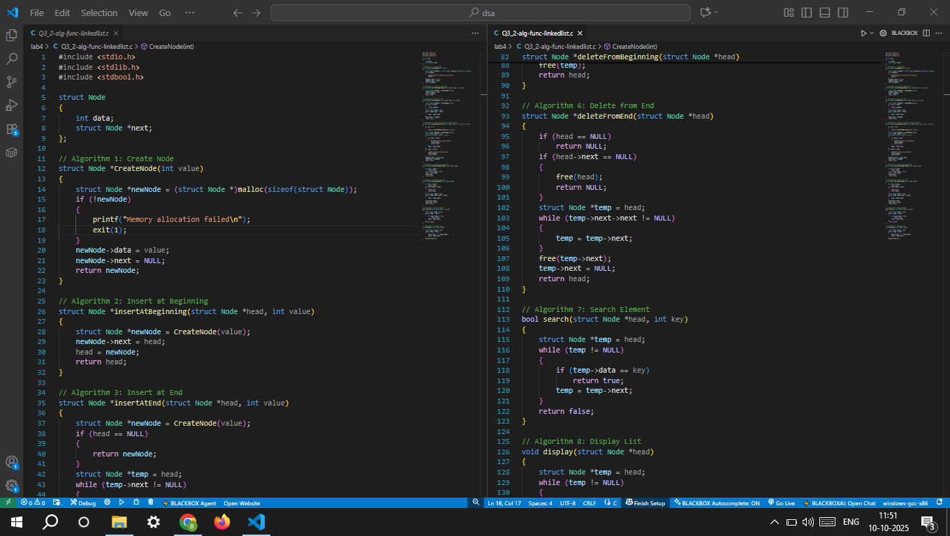

Q4. Write a main() function that:
• Declares and initializes the linked list • Displays a menu with choices for each operation • Takes user input for choice • Calls the appropriate function accordingly

Sample menu format: 1. Insert at Beginning 2. Insert at End 3. Insert at Position 4. Delete from Beginning 5. Delete from End 6. Delete a Node 7. Search an Element 8. Display List 9. Exit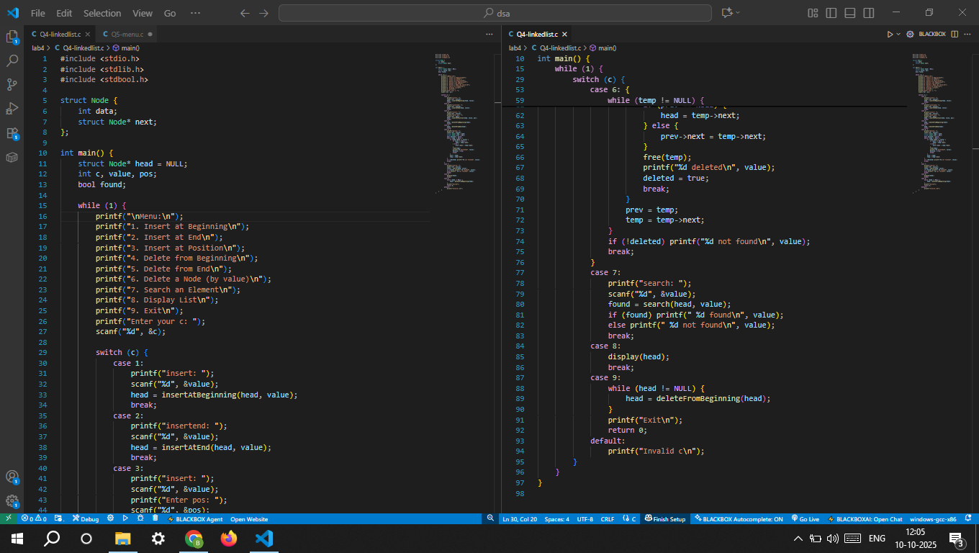

Q5. Combine all code snippets into a single working file for Singly Linked List. Test each operation thoroughly with sample input/output.
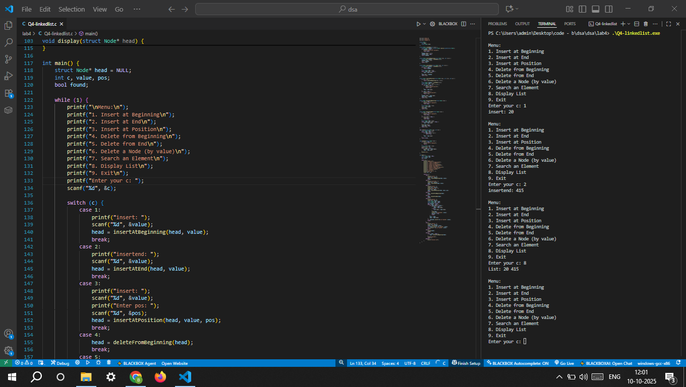

Q6. Create a program for the implementation of a Singly Linked List with all operations in C++.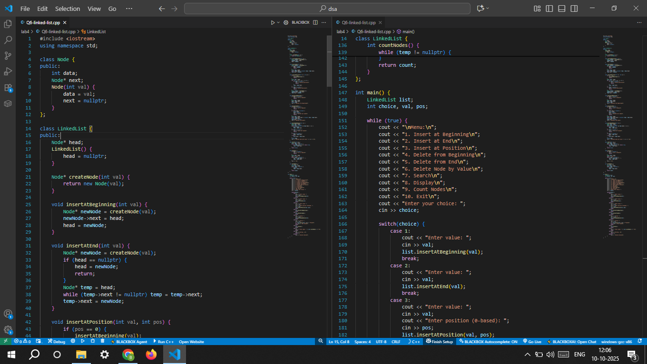

Doubly Linked List
Q7. Write the code snippet to define a Node structure for a Doubly Linked List in C/C++.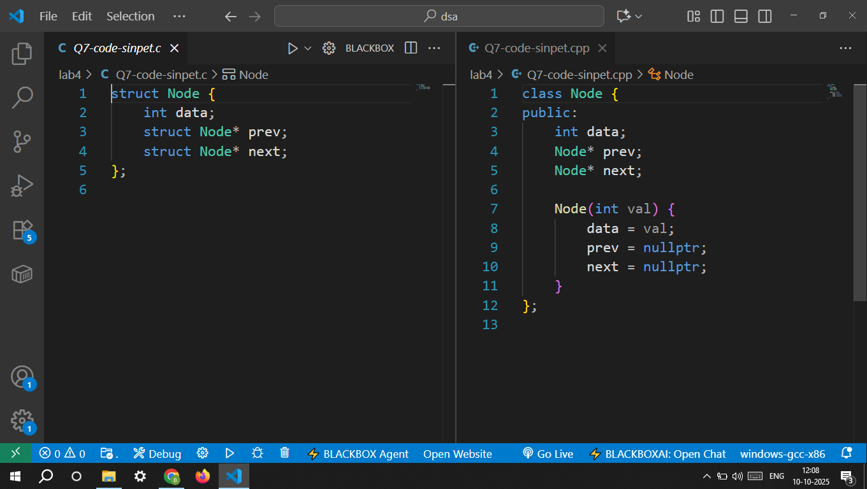

Q8. Write function prototypes for the following operations:
• Create a new node • Insert at beginning • Insert at end • Insert after a specific position • Delete from beginning • Delete from end • Delete a specific node • Search an element • Display forward • Display backward 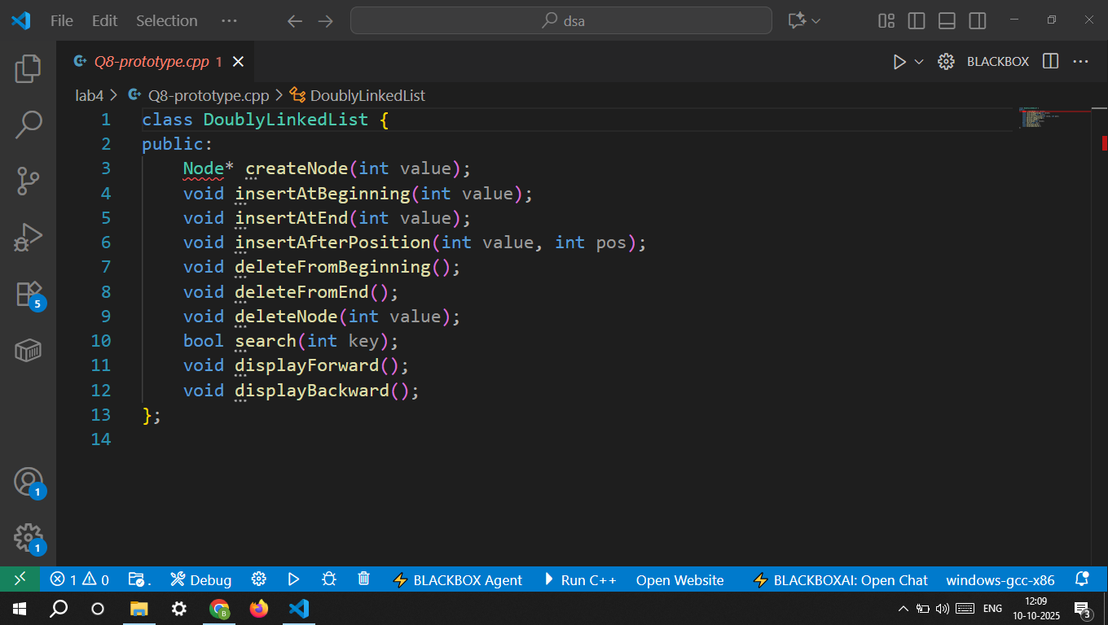

Q9. Read the following Algorithms for DLL Operations and implement them in C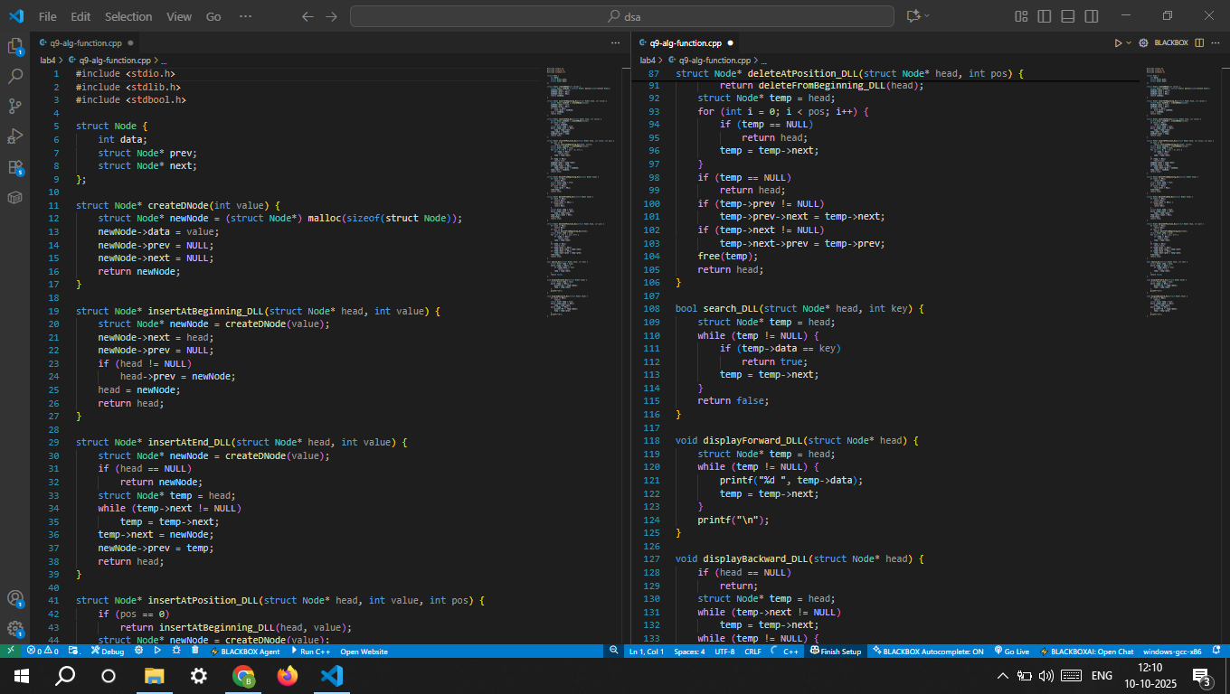

Q10. Write the code snippet for each operation using your algorithm logic and the structure: struct DNode* insertAtBeginning(struct DNode* head, int value) { // code here } 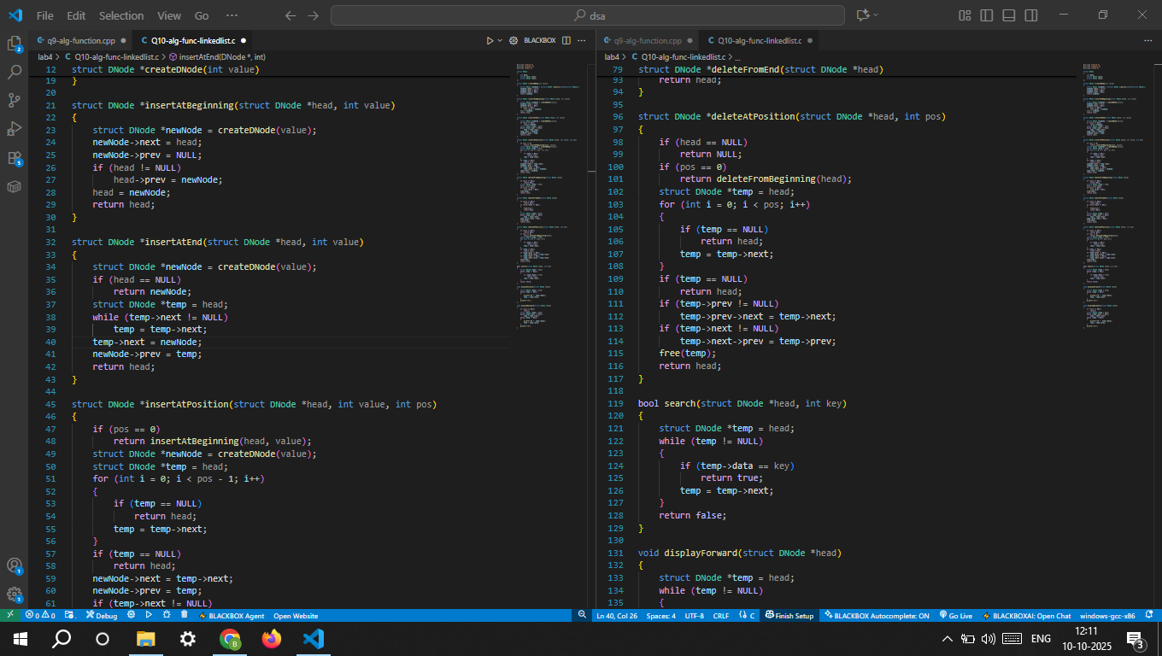

Q11. Write a main() function for Doubly Linked List similar to Q5 but including: • Display forward • Display backward Sample menu format: 1. Insert at Beginning 2. Insert at End 3. Insert at Position 4. Delete from Beginning 5. Delete from End 6. Delete a Node 7. Search an Element 8. Display Forward 9. Display Backward 10. Exit
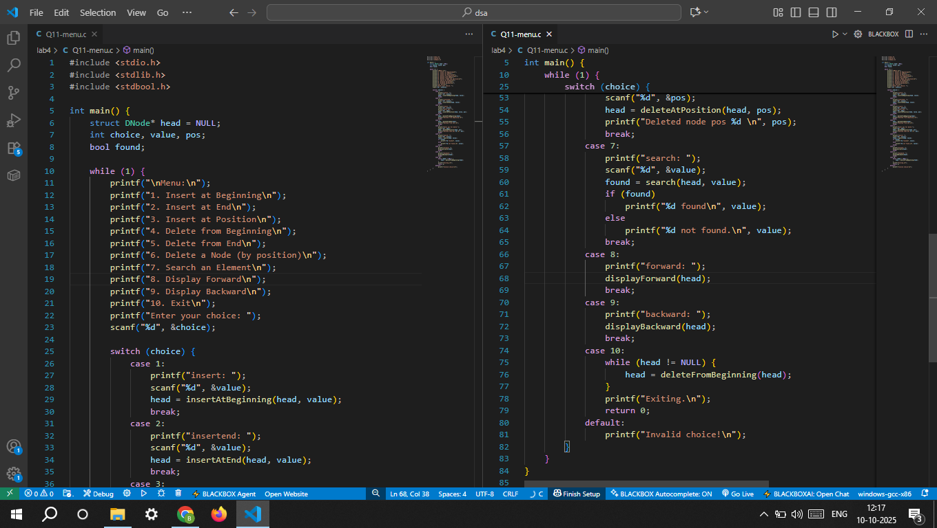

Q12. Combine all code snippets into a single working file for Doubly Linked List and test all operations.
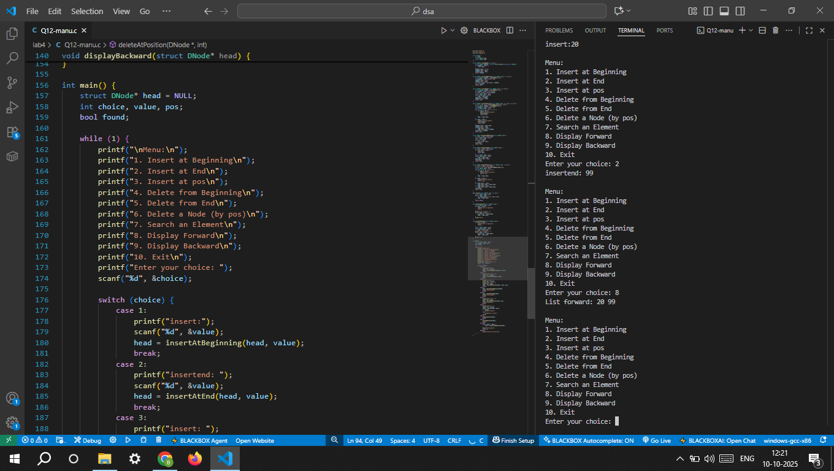

Q13. Create a program for the implementation of a Doubly Linked List with all operations in C++. 